**UNIVERSITY MANAGEMENT SYSTEM**

Group 3

Team members:

Chathuni

Mandeep

Gagandeep

Vivek(leader)

Studio1

Year:2024

# 

Table of Contents

Executive Summary 3

What information will the system offer the user? 4

What data will be stored by the system? 5

Where does we get this data? 6

Who are the target users? 7

List of Use Cases which our system is implement 8

How and why this system is useful? 10

What are the similar systems? 11

How our system is different from comparable systems? 13

Diagram 15

Team members Contribution: 16

# Executive Summary

The purpose of the report is to demonstrate the university's school management system which is a very usable website hence user-friendly. For the students, it is a one-stop shop where they can do all these - paying school fees, registering for classes, and accessing their academic records with few clicks.

(Lauda et al.,2016).

The easy-to-use course management techniques, the simple grading mechanisms, and quick access to student information are the tools that help the educators to share the information quickly among themselves. On the contrary, those in the leadership roles are quite happy with the data-centred dynamic that provide information, coordinate all the internal resources, and centralized management of the operations of learning to make sure that everything is working as planned. This is the final game changer as it ensures all the participants a convenient and well-organized university experience.

(Microsoft Education,2019).

Reference: Lauda, K., Mustapha, N., & Mohammed, S. (2016). User interface design of learning management systems: A review of the literature.

<https://dribbble.com/tags/learning-management-system>.

Microsoft Education. (2019, April). The modern university: Five key strategies for improving the student experience. <https://info.microsoft.com/ww-landing-McKinsey-Class-Of-2030-Whitepaper.html>.

# What information will the system offer the user?

Depending on the user type, the university management system offers different information:

For Students, academic life just got easier. With the new school management system have everything at their fingertips. Grades, transcripts, progress reports, materials, course schedules, descriptions, instructors can easily be available to students at one site. It will also help students to save lot of time.

For lecturers, this system streamlines course management with attendance tracking, grade recording. Individual student profiles provide insights into academic performance, while communication channels keep them connected. Also, they get valuable reports on class engagement and feedback. By this way it will help lecturer to refine their teaching strategies and empower student success.

For administrator, we had two administrator such as course administrator and fees administrator their work is to get in-depth reports on student academic trends, course enrolment, and finances. Manage everything – student records, assessment, courses, faculty, fees, and financial aid – from one central platform.

Overall, the all-encompassing features of the system cater to the needs of all users, fostering a more connected and transparent university community. With a centralized platform, individuals can seamlessly access announcements, participate in forums, and engage in messaging, promoting improved communication across the board. The emphasis on increased transparency ensures that all users have effortless access to pertinent information, nurturing a collaborative environment. Moreover, the system's user-friendly interface and self-service functionalities contribute to an enhanced overall user experience, making interactions with the platform easy and efficient for everyone involved.

# What data will be stored by the system?

**Student:** student id, personal information such as their names. Contact information such as their phone number and email.

**Lecturer:** lecturer id, lecturer name, lecturer contact information: email and phone.

**Course:** course name, course id, course duration, credits, level.

**Subject:** subject id, subject name.

**Fee administrator:** admin id, name, email

**Course co-ordinator:** co-ordinator id, name, email.

**Fee:** fee id, amount, due date.

**Class**: class id, capacity.

**Department**: department id, department name.

# Where does we get this data?

The student information could be collected from the university's registrar's office.

The course information could be collected from the university's course catalogue.

The fee information could be collected from the university's office.

The class information could be collected from the university campus.

The lecturer information could be collected from the course department of university.

The subject information could be collected from the course department of university.

The department information could be collected from the university campus.

The course co-ordinator information could be collected from the administration office in the university.

The fee administrator information could be collected from the administration office in the university.

For testing purpose, we will use dummy data to make sure that our system is running properly.

# Who are the target users?

* Students
* Administrators
  + Fee Administrator
  + Course Co-ordinator
* Staff
  + Lecturers

# List of Use Cases which our system is implement

Students:

1. Course:

* view course, description, instructors, and materials.

Also, student can register themselves for courses and manage their schedule.

1. Academic records:

* Students can view grades, transcripts, and progress reports. Also, they can request transcript.

1. Communication:

* Student can message to their classmate, faculty, and staff.

1. Self-service:

* Student can pay fees online for their study as well as update personal information and contact details.

Administrators:

1. Data analysis and reporting:

* Have detailed access reports to student enrolment, academic performance, course data and financial information.
* Make data-driven decisions for constant improvement of the university.

1. System Administration:

* Manage user accounts and permission.
* Monitor system performance and troubleshoot technical issues.

Staff:

1.Student Support:

* respond to student inquires and request via email, phone or online chat.
* Manage student records.
* Help student with registration, financial aid.

2.Course management:

* Assist faculty with course setup, enrolment management and grading.
* Upload course materials and resources.

3.Faculty Support:

* Provide technical assistance to faculty with the learning management system.
* Manage faculty account permission and access permissions.

4.Reporting and data collection:

* Make reports on particular area such as student attendance, course enrolment.
* Analyse data and identify potential issue and area of improvement.

# How and why this system is useful?

This system could be useful in several ways, such as:

**Improving efficiency:** The system could automate many tasks that are currently done manually, such as registering for courses and paying fees. This could save students, faculty, and administrators time and effort.

**Improving communication:** The system could provide a central platform for communication between students, faculty, and administrators. This could improve communication and collaboration.

**Providing data-driven insights:** The system could provide administrators with data-driven insights that they can use to make better decisions about the university**.**

# What are the similar systems?

The current available system is:

**BYJU'S:**

Focus: Online learning platform offering personalized learning experiences, interactive content, and assessments for students.

Target users: Students, parents, and educators.

Services: Adaptive learning, live classes, personalized learning plans, practice questions.

Accessibility and affordability: Offers freemium(scholarship) as well as premium plans.

Reference: https://byjus.com/learning/

**UpGrad:**

Focus: Upskilling and reskilling professionals through online and blended learning programs in various fields like management, data science, blockchain, etc.

Target users: Working professionals aiming for career advancement or skill development.

Services: Online courses, live sessions, mentorship, career support, etc.

Accessibility and affordability: Tuition fees vary depending on the problem.

Reference: https://www.upgrad.com/nz/

**Blackboard:**

Blackboard can be a competitor to your school management system, depending on the specific features and functionalities our system offers.

Focus: Learning management system (LMS) for educational institutions, primarily K-12 and higher education.

Target users: Educators, students, and administrators.

Services: Course management, communication tools, assessment tools, collaboration features, reporting.

Accessibility and affordability: Varies depending on the institution and features.

Reference: https://www.blackboard.com/

# How our system is different from comparable systems?

In our system solely focuses on administrative functions like student records and finances, it wouldn't directly compete with Blackboard's and other platform are focusing on learning delivery. Our school management system offers course management features like online learning modules, assessments, and communication tools, it directly competes with Blackboard in that area.

Even if our system does not offer full LMS (learning management system) functionality, it may still compete with Blackboard because our target audience is the same, such as universities or colleges.

There are certain factors such as Technology, Focus, Targeted audience, Accessibility and Affordability that makes our system different from others. To commence with, in terms of targeted audience, UpGrad has targeted professionals seeking career advancement or upskilling in specific fields. Byju’s targeted audiences are student (k-12 and early childhood), parent and educators. Blackboard targeted audiences are educators, students and administrators in educational institutions and student (k-12 and higher education). Our System targeted audiences are Universities, faculty, parents.

In term of technology, UpGrad blends on online learning with live session and personalized support. While the Byju’s use interactive content, gamification as well as adaptive learning. On the other hand, Blackboard established Learning management system and might be not using latest technologies. Our system is not offering a latest technology such as Ai. Furthermore, in terms of focus UpGrad highly focuses on online as well as blended learning programs for professional development. Byju’s has a personalized learning experience, interactive content and assessment for k-12 and early childhood education. Which make this platform successful in this competitive environment. Blackboard has keen focus on course management, communication, assessment, and collaboration tools for educational institutions. In the flip side, our system we focus on student information management, administrative tasks, course management for university student, physical education, and online education.

# Diagram

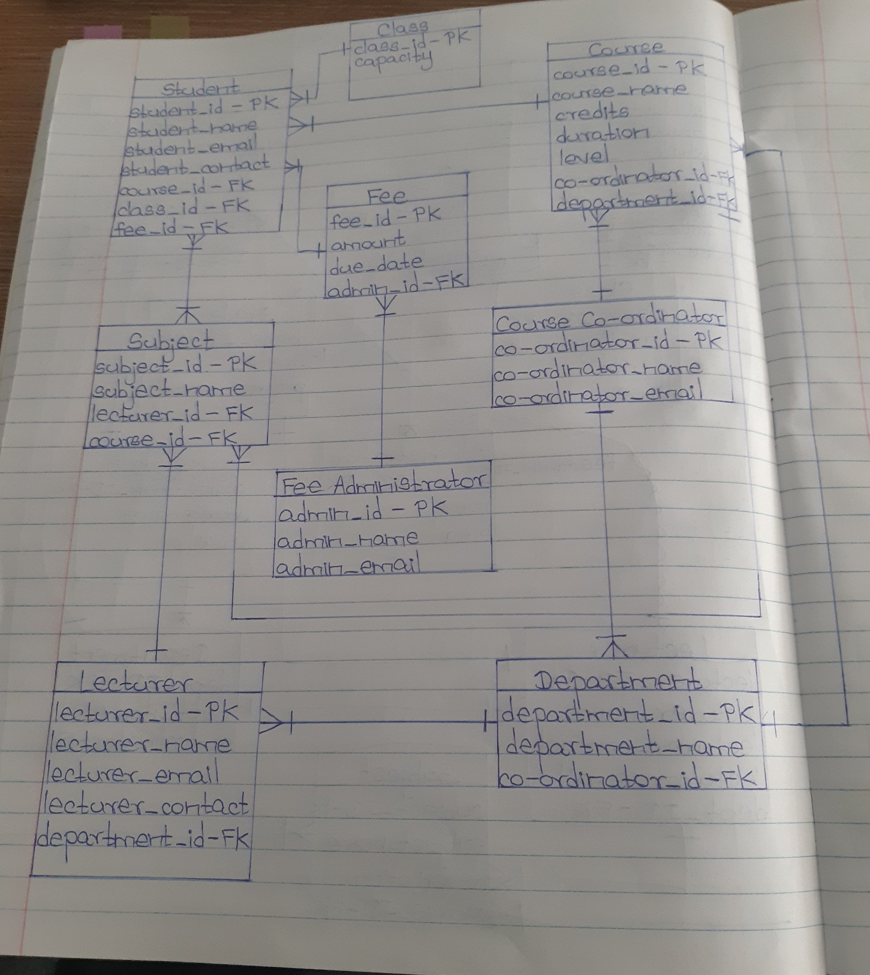

# Team members Contribution:

Chathuni: I had given her task of making summary and system to find comparative systems. She had done her work perfectly but the backup which I made for our draft proposal seem more detailed, so I added mine one instead of her because it is detailed and able to meet word count.

Vivek (Leader): I had made the whole proposal, but Chathuni helped me to find some mistakes and helped me in final diagram, she also made a diagram. But I had made a new diagram combining mine and her ideas at last movement to look tidier.

Others team: None contributed to proposal.